Based on our analysis of inbound NZ tourism data, focusing on visitor numbers by country of origin from the year-end data from 2020 to May 2024, we have identified the following insights:

1. **Key Findings**:

a. **Total Visitor Trends**:

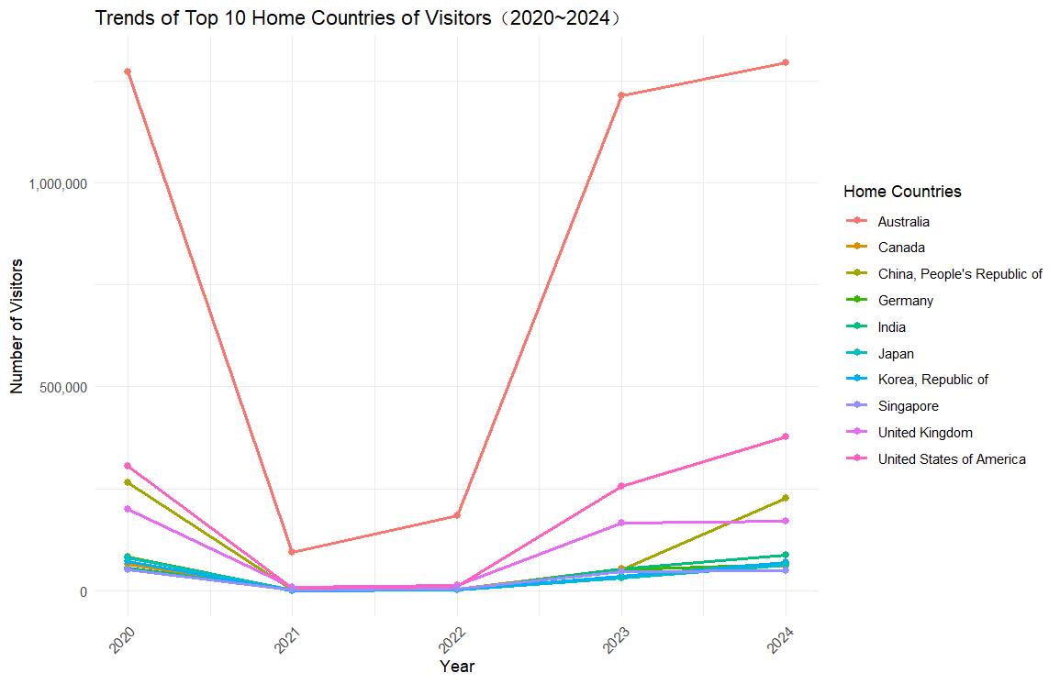

* + Australia remains the leading source of visitors to New Zealand. Although visitor numbers dropped significantly in 2021 due to the pandemic, they rebounded quickly and remained strong in 2023 and 2024.
  + The United States and the United Kingdom also experienced a rapid recovery after 2022, with steady growth through 2023 and 2024.
  + China and Japan showed continuous growth in visitor numbers, particularly China, which experienced a sharp rebound from the low point in 2021.
  + European countries like Germany and France also showed slow but steady growth in tourist numbers.

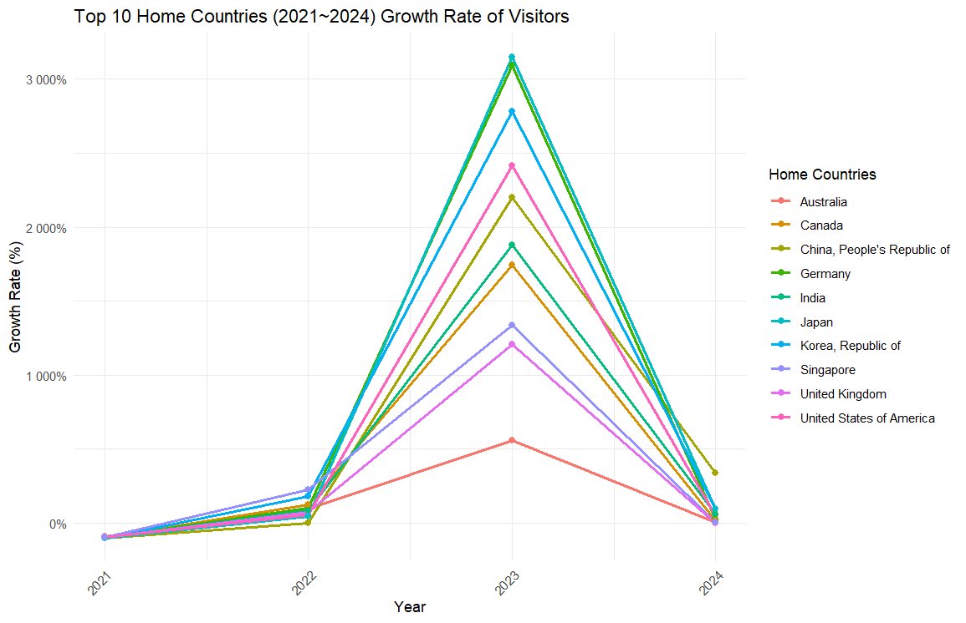b. **Yearly Growth Rates**

* + Australia and the United States exhibited high recovery rates after 2021, with both countries showing significant growth in 2023 and 2024.
  + China also demonstrated remarkable growth after 2022, standing out as the fastest-growing non-English-speaking market.
  + European countries like Germany and the UK maintained relatively stable growth but still showed positive trends.
  + Japan and South Korea displayed a steady upward trend, indicating a stable recovery of tourists from these countries.

1. **Market Insights and Recommendations**:

a. **Growth in Non-English-Speaking Countries & Value-Added Services**:

* + Non-English-speaking countries such as China, Japan, and Germany are seeing noticeable increases in visitor numbers. This suggests a need for targeted value-added services for these markets.
    - **Language Support**: Consider increasing multilingual signage translation services and offering official tourism websites in Mandarin, Japanese, and German.
    - **Tour Guide Services**: Employ more tour guides who speak these languages, especially in popular tourist attractions, to enhance the visitor experience.
    - **Customized Tourism Products**: Tailor travel experiences and tours to fit the cultural preferences of these countries, such as shopping tours for Chinese visitors or nature adventure tours for German tourists.

**b. Resource Allocation Recommendations**:

* + **Focus on Australia and the U.S.**: Australia remains New Zealand's largest visitor market, with a high growth rate in 2023 and 2024. Continued investment in infrastructure and services for Australian tourists is essential. The U.S. is also rapidly expanding, particularly in the luxury and independent travel segments, making investing in high-end hotels and boutique resorts worthwhile.
  + **Increased Focus on the Chinese Market**: China's visitor numbers have recovered significantly after 2022, making it a critical market to focus on. Marketing efforts should be strengthened by utilizing social media platforms like WeChat and Xiaohongshu (Little Red Book) to target younger Chinese travelers.

c. **Infrastructure and Guide Preparation**:

* + **Increase Foreign Language Guides**: As the number of tourists from non-English-speaking countries such as China, Japan, Korea, and Germany grows, the demand for foreign language tour guides will rise. Tour operators should invest in multilingual guide training and ensure that staff at major attractions have basic foreign language skills.
  + **Innovative Tour Solutions**: Develop multilingual tourism apps or smart guide devices that allow tourists to access information quickly without a guide. This is particularly useful for tech-savvy markets like China and Japan, where digital solutions are highly valued in the travel experience.

d. **Tourism Projects and Marketing**:

* + **Customized Projects for High-Growth Markets**: For countries with high growth rates, such as the U.S., Australia, and China, tailor specific offerings like eco-tourism, cultural experiences, and adventure tours to meet their preferences.
  + **Advertising Strategies**: As tourism recovers post-pandemic, social media and digital advertising will be key in attracting international visitors. Targeted campaigns should be run for each country, significantly leveraging local social media platforms and search engines in China and the U.S.

1. **Conclusion**:
   * New Zealand's tourism market is rapidly recovering from the pandemic, with visitors from Australia, the U.S., and China leading the way. Tourism providers should offer customized services and experiences tailored to different markets. Investments in foreign language guides, multilingual facilities, and digital guide solutions will ensure New Zealand remains an attractive destination for international visitors and delivers high-quality tourist experiences.